The Economic Impact of Commercial Fire Incidents in Louisville in 2021

Sida Wan

Ph.D. at the University of Louisville

Ryan Gill

Professor at the University of Louisville

1. Introduction

The Fire department of Louisville aimed to provide public-safety service for the community. With over 500 highly trained men and women. The department responds to over 40,000 incidents per year. Not only protecting lives and property through fire incidents and assisting in all kinds of emergencies.

In this article, we will study the economic impact of the commercial fire incidents that happened in 2021 in Louisville.

1. The data set

By analyzing the open data from data.louisvilleky.gov. 43568 incidents happened in the year 2021 that was recorded. There are different categories of incidents. The category with the most incidents is "Rescue and emergency medical service,” which was more than half of all the incidents (see Figure 1). Meanwhile, the number of fire incidents was only 4.79%.

We want to draw an insight from the commercial fire cases; hence the fire incidents would be the category we will be working on.

After extracting all the fire incidents from the dataset, we found out that there were 1879 in total. Among those incidents, there are 30types of fire incidents, such as outside rubbish fire, passenger vehicle fire, etc. We will be mainly focusing on building fire.

1. Commercial fire analysis

There were 60 building fire incidents in total in 2021, which will be considered the primary targets for analyzing the impact of commercial fire.

When a fire incident happens, officers from the fire department will estimate the property loss for the incident. And the property value of such a building will be recorded too. However, there was a couple of data missing; among the 60 data recordings for a building fire, only 49 of them had estimated loss in the data set. However, we can do some estimation by their category of commercial organizations.

In the commercial fire incidents, there are six different types of commercial organizations; the special category would be "Storage", we don't know the company type. Below (Figure 2) is the distribution of commercial organizations in the fire incidents.

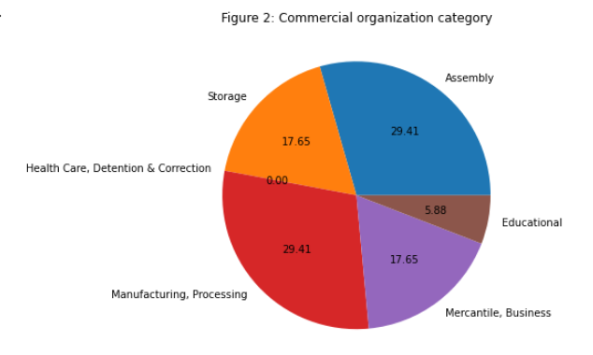

From the estimated damage for each of the fire incidents. We can sum up the value for the total loss for each type of commercial fire (see Figure 3).

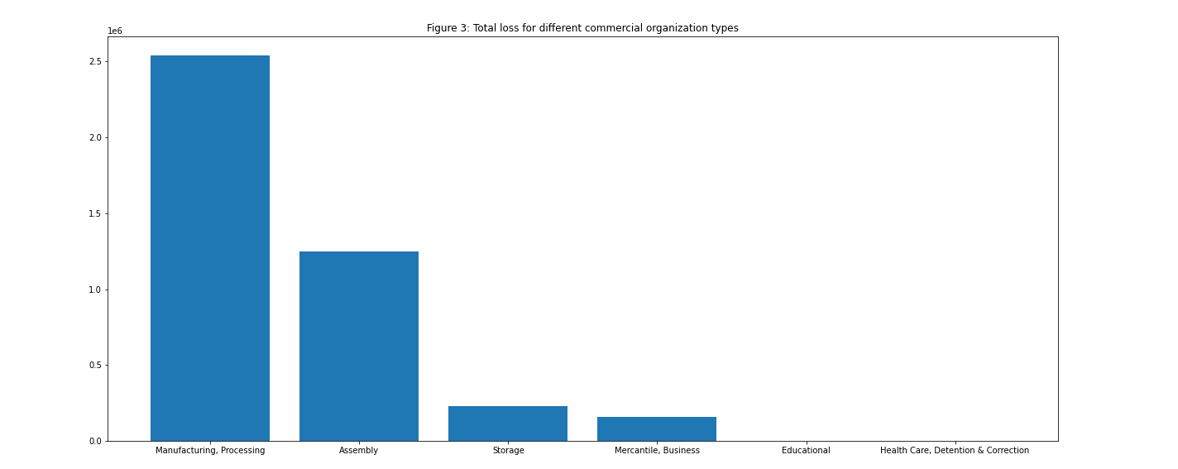

We can tell from the plot that the direct loss in the Manufacturing and processing industry had the most significant amount of total loss among all the commercial fire types. Although the case where the fire took place in storage had the largest portion in number, which is 68.75%, the total loss is about half compared to the manufacturing and processing industry, where only count 10.42% of the incidents.

Here we list the actual value of the estimated and recorded loss.

|  |  |
| --- | --- |
| Industry type | Amount of direct losses ($) |
| Manufacturing & Processing | 2,540,000 |
| Assembly | 1,247,460.0 |
| Storage | 230,000.0 |
| Mercantile & Business | 157,000 |
| Educational | 2,500 |
| Health care, detention, and correction | 3,000 |

The sum of the total loss for all the commercial fires is 4,177,960 dollars.

1. Dealing with missing values

Since seven commercial fire incidents had the estimated damage is missing. However, the industry type of the building was recorded; we can use the average value for the missing direct property loss.

First, let’s see the number of the different types of industrial buildings and the number of the industry type of the missing 11 buildings in the fire incidents table.

|  |  |  |
| --- | --- | --- |
| Industry type | Count (total) | Missing |
| Manufacturing & Processing | 7 | 2 |
| Assembly | 6 | 1 |
| Storage | 3 | 0 |
| Mercantile & Business | 7 | 4 |
| Educational | 1 | 0 |
| Health care, detention, and correction | 1 | 1 |

Use the average to calculate the estimated direct loss for the 11 incidents. The estimated total losses for fire in each industry type are in the table below.

|  |  |
| --- | --- |
| Industry type | The estimated amount of losses ($) |
| Manufacturing & Processing | 3,556,000 |
| Assembly | 1,496,952 |
| Storage | 230,000 |
| Mercantile & Business | 366,333 |
| Educational | 2,500 |
| Health care, detention, and correction | 3,000 |

The estimated total is: $ 5,654,785

1. Indirect loss

Indirect losses are the most difficult cost component to estimate. One common method is to use REMI, an economic forecasting tool used to study the economic impact in a given region.

However, some data can be used to estimate the indirect loss. We use the formula listed by NFPA(TODO) to calculate the indirect losses:

We divide the industry into three categories. Category 1 includes fire in manufacturing or industrial structures; category 2 includes fire in the public assembly, educational, institutional, store, or office structures, whereas category 3 includes fire in residential, storage, or special structures. The indirect damage for those three categories would be the product of the total direct damage and a coefficient of 0.65, 0.25, 0.10, respectively. Finally, we will estimate the indirect damage of closed business which is calculated as:

$$4×2\%×(direct damage in reported fires in non-residential structures).$$

In our case, fire in Manufacturing & Processing structure, Assembly would be classified in category 1. Fire in Educational, Mercantile & Business, Health case, detention, and correction fire are in category 2, and we have the fire in storages in category 1. Hence the indirect losses for the 49 commercial fires are:

$$3556000×65\%+\left(1496952+366333+2500+3000\right)×25\%+230000×10\%+4×2\%×5654785=3253979.05$$

1. Saved values

The table also recorded the saved values of each incident. Notice that it’s the property value before the fire subtracts the direct loss. There are a few negative values due to the property price being too few, and the total estimated loss exceeds it. The reason for that is the estimation for property value is recorded in the government’s data set. However, there may be direct damage for the objects such as furniture and personal belongings that are more than the property value. Hence, we will just replace the negative saved amount with 0.

We then can calculate the property that could potentially be damaged by the commercial fire. Again, we will put them in the following table classified by industry type.

|  |  |
| --- | --- |
| Industry type | The recorded amount could be saved ($) |
| Manufacturing & Processing | 612,990 |
| Assembly | 277,615.0 |
| Storage | 892,040.0 |
| Mercantile & Business | 52,987,240 |
| Educational | 997,500 |
| Health care, detention, and correction | 1,998,500 |

Again, we use the average amount of saved value to estimate the missing amount that could be saved, and the following form is the estimated value for the total amount that could be saved.

|  |  |
| --- | --- |
| Industry type | The estimated amount could be saved ($) |
| Manufacturing & Processing | 858,186 |
| Assembly | 333,138 |
| Storage | 892,040.0 |
| Mercantile & Business | 123,636,893 |
| Educational | 997,500 |
| Health care, detention, and correction | 1,998,500 |

From the table, we can calculate the total amount of property that was affected and could have been damaged by commercial fires is: $128,716,257.

Reference

NFPA. 2014. The total cost of fire in the United States. Tech. rep. URL: http://www.nfpa.org/news-an d-research/fire-statistics-and-reports/fire-statistics/fires-in-the-us/overall-fire-problem/total-cost-of-fir e, accessed in October 2017.

NFPA. Total Cost of Fire in the United States. 2017. Tech. rep. URL:

<https://www.nfpa.org//-/media/Files/News-and-Research/Fire-statistics-and-reports/US-Fire-Problem/RFTotalCost.pdf>

The University of Central Florida. 2014. The Economic Impacts of Successful Orange County Commercial Fire Interventions. URL: https://ccie.ucf.edu/wpcontent/uploads/sites/12/2018/11/report-EconomicImpactsofSuccessfulOrangeCountyCommercial-FireInterventions.pdf